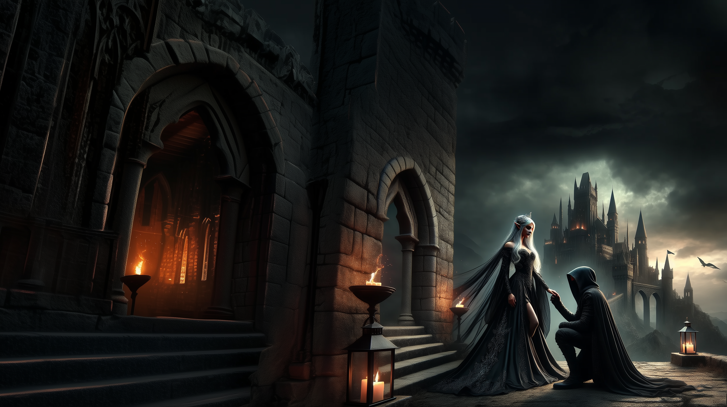

|  |
| --- |
| **The Princess and the Rogue - By Trevy Burgess** |